Terraform-Jenkins Assesment -

* Added webhook for jenkins –

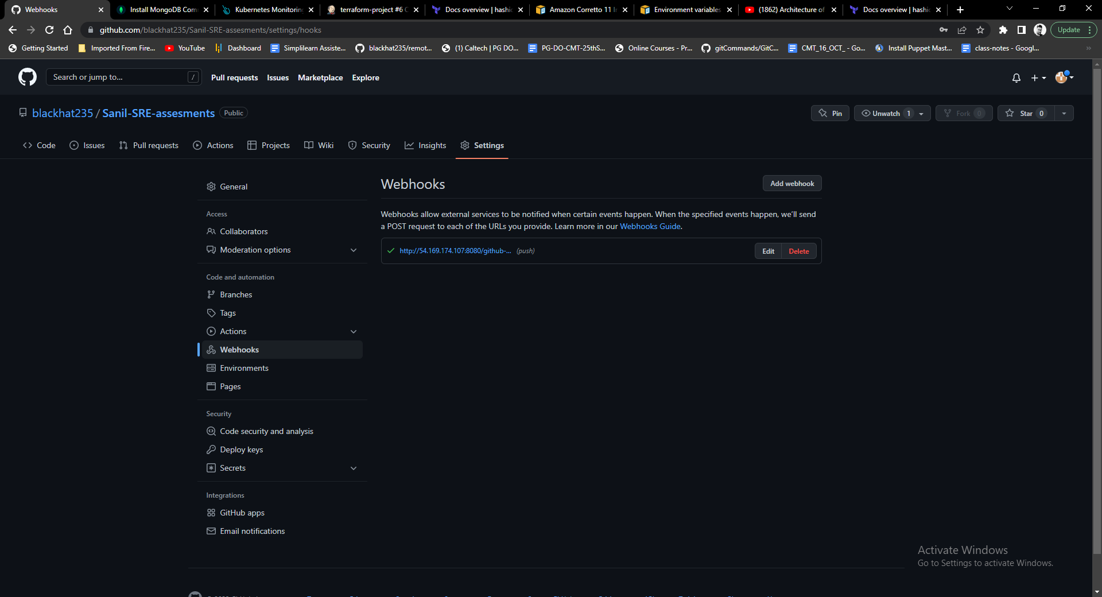

* Jenkins Job build successful –

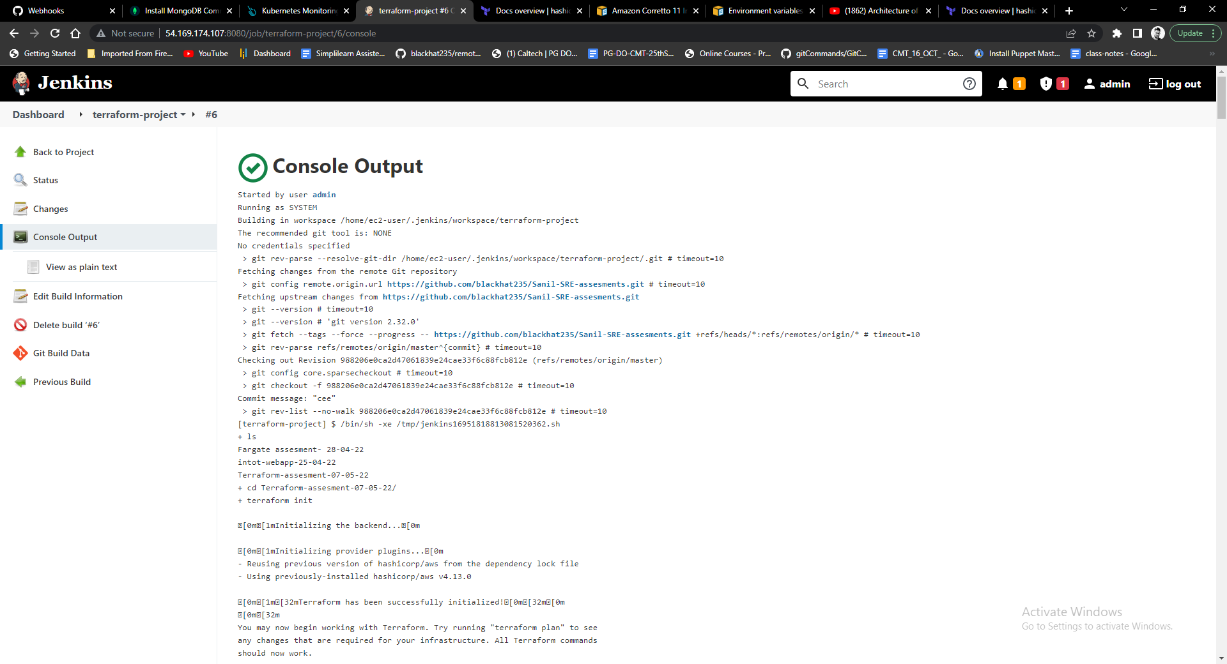

* Prometheus plugin added –

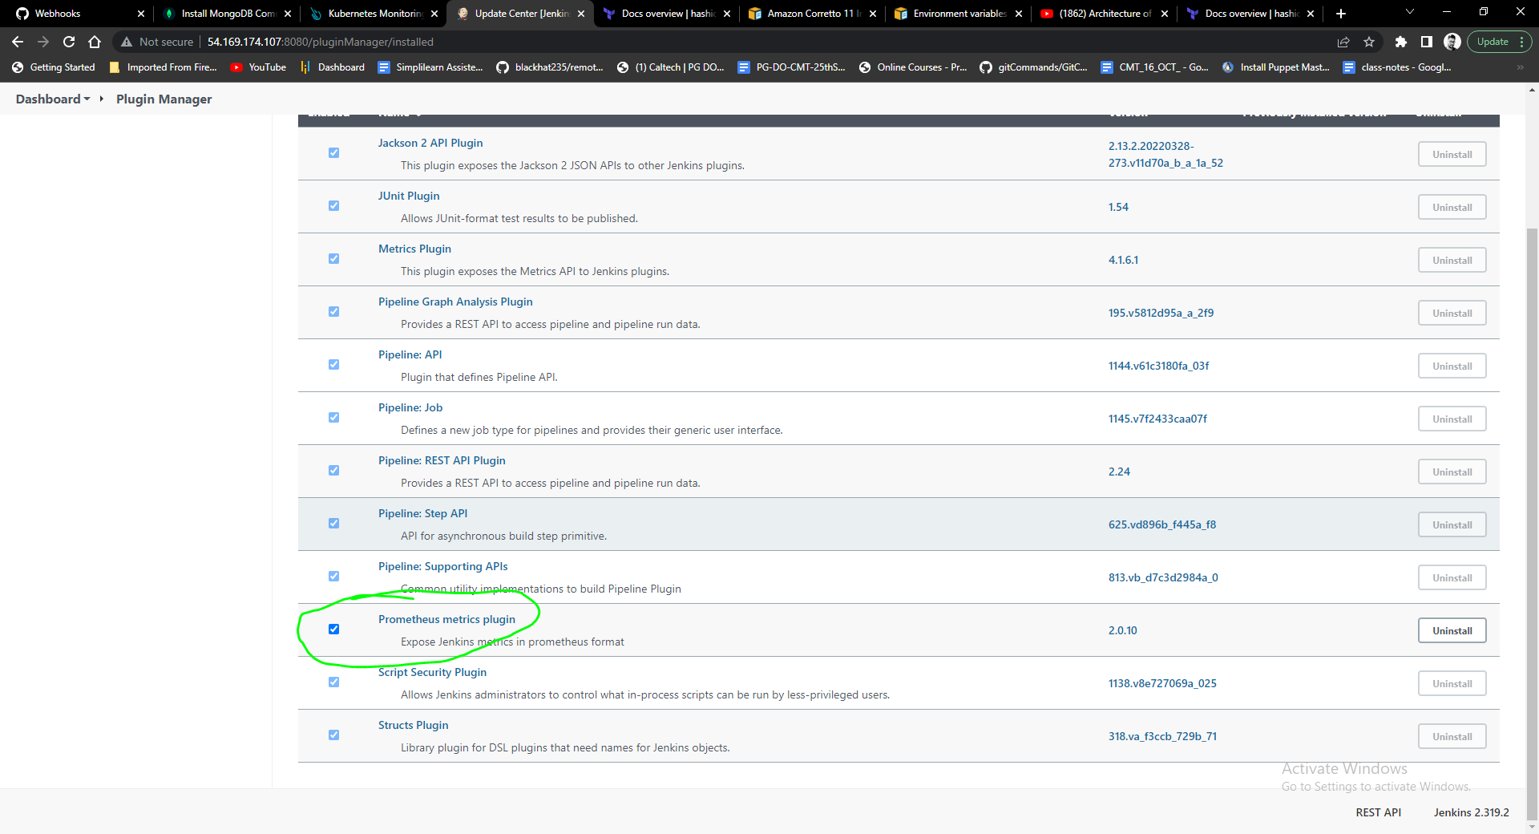

* Jenkins metrics exposed using promethus – URL - http://54.169.174.107:8080/prometheus/

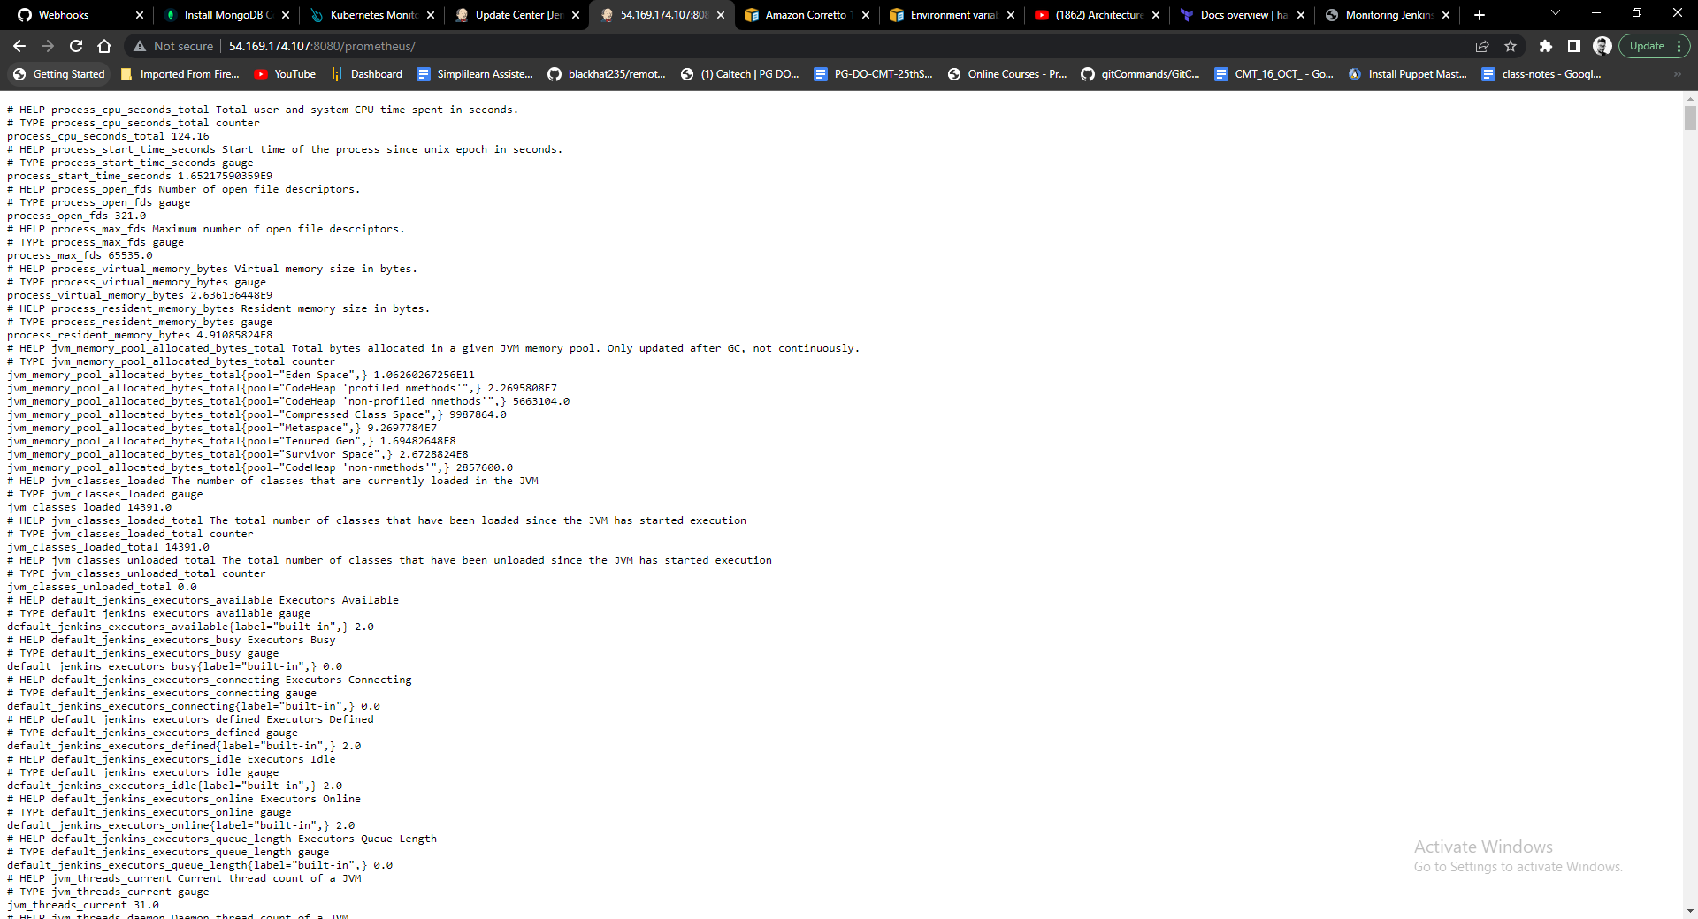

Graphana visualization for jenkins metrics :

